**Glucono-Delta-Lactone and Calcium Carbonate reaction experiment**

August 18th, 2022.

*Introduction:* This write-up discusses the process of performing GDL and CaCO3 experiments.

*PPE:* Safety glasses, Lab Coat, Safety Gloves

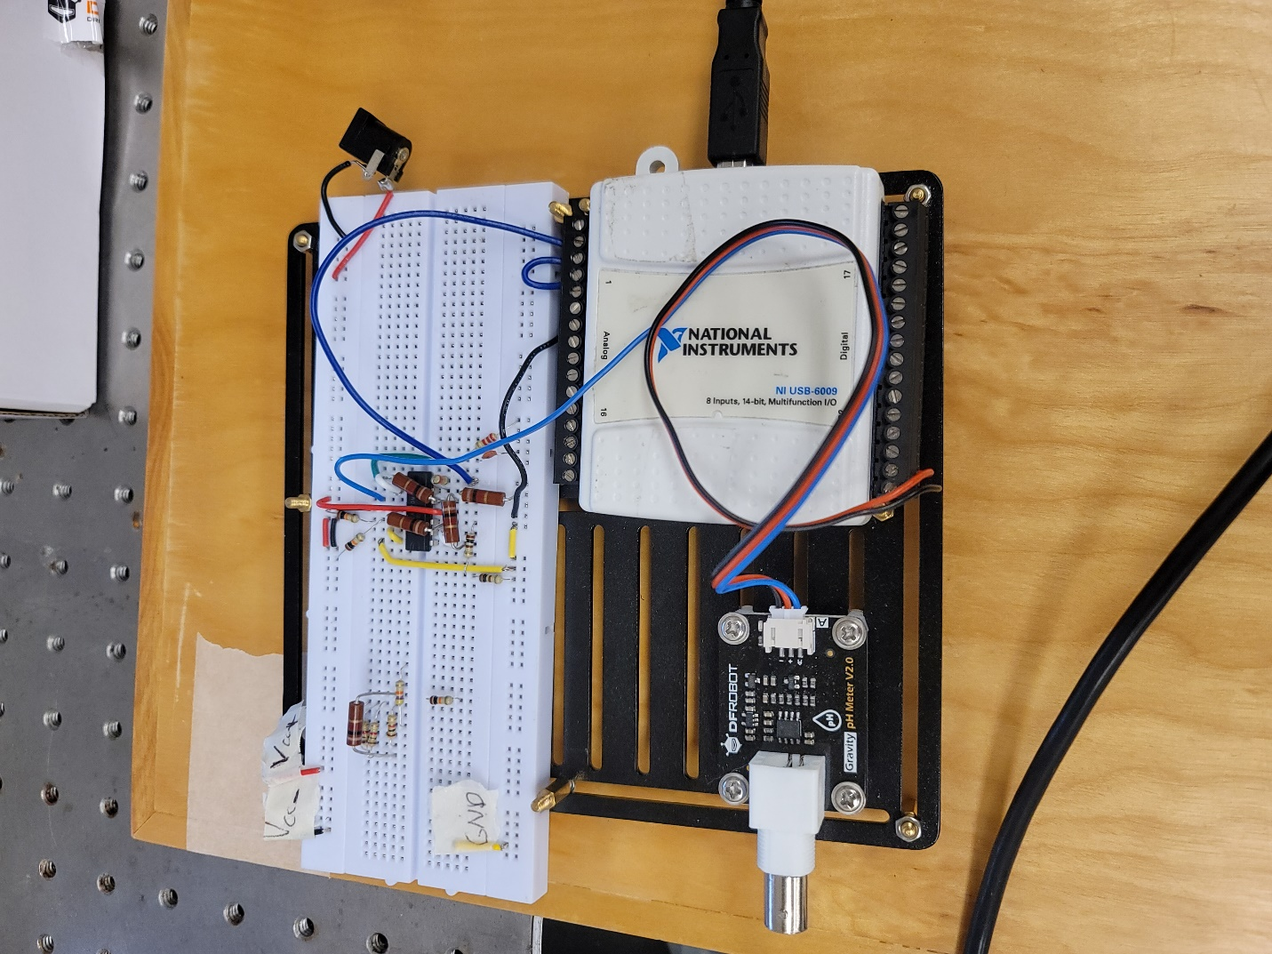

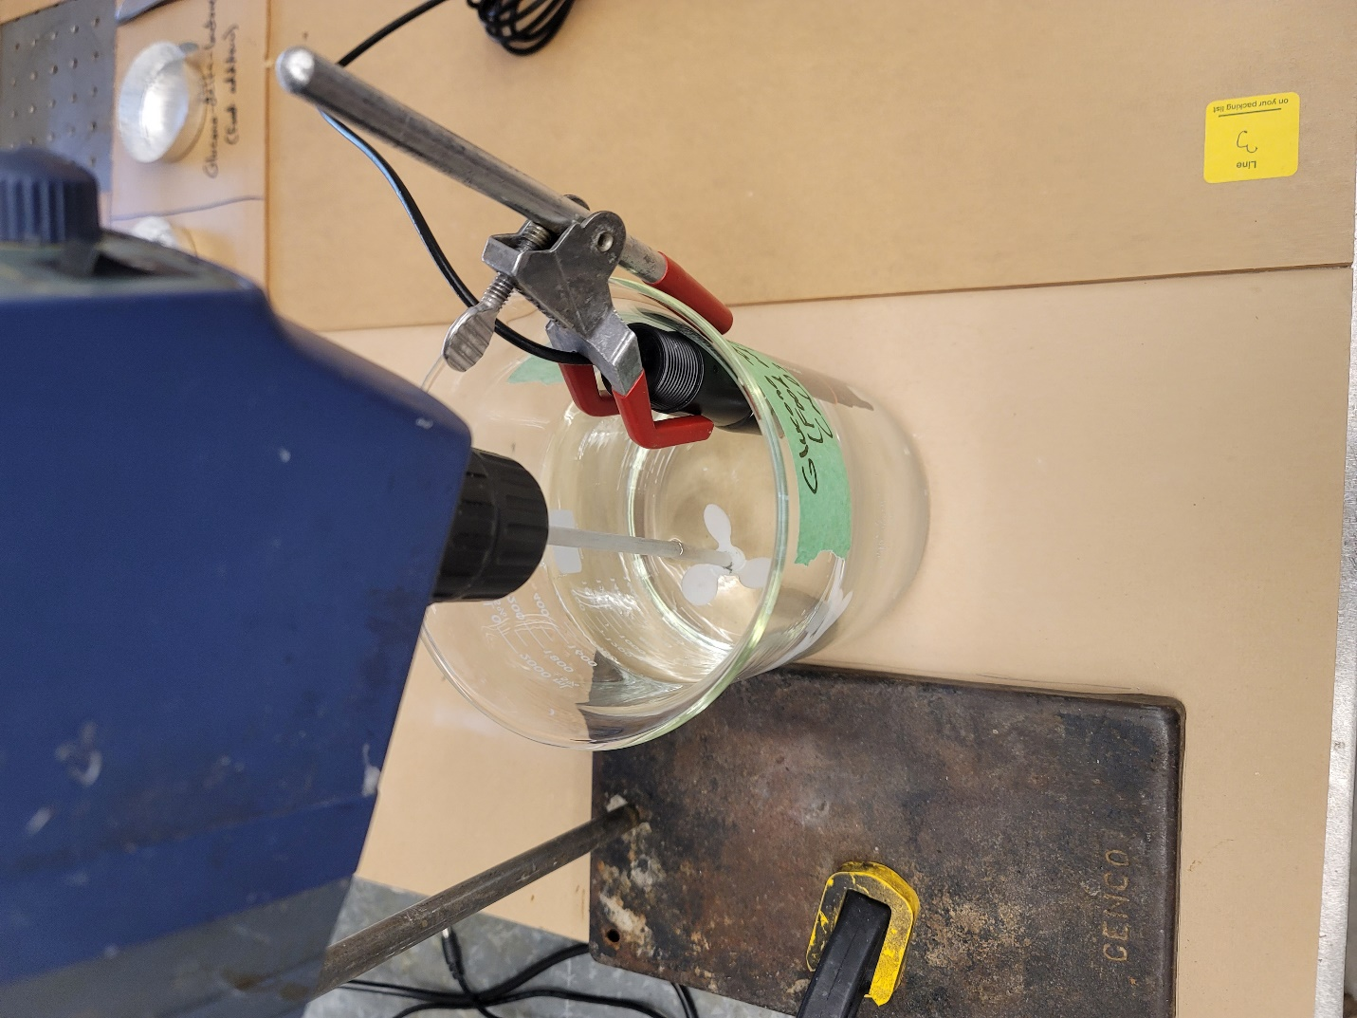

*Procedure:*

1. Ensure that the work area is clear and uncluttered.
2. Plug USB from NI DAQ into computer and attach pH probe to circuit side connector.
3. Set up overhead mixer to the left of the electrical components, ensuring that there is no chance of water touching any sensitive electronics. Refer to overhead mixer SOP.
4. Calibrate pH probe using 3 buffer solutions using the provided software control scheme. Refer to pH probe SOP.
5. Gather experiment components, including X grams of GDL, Y grams of CaCO3, and Z grams of water in a 1L beaker. Suggested total mass is around 1200g.
6. Place water beaker under overhead mixer and begin stirring to agitate the water. The plastic impeller needs to be moved as far to one side of the beaker as possible so there is room for the pH probe to sit.
7. Stop the overhead mixer and attach the pH probe to the side of the beaker via red clamp, put the pH probe as low as possible to reduce noise from bubbles and the impeller.
8. Run the data collection software for the pH probe with the calibrated model from before. Begin stirring the overhead mixer again to around 900RPM, ensuring that no liquid is being thrown out of the beaker. If any is, decrease the RPM such that mixing will occur but there are no losses.
9. Wait for the pH data to decrease until it has a constant mean, often the pH varies after initial stirring and this can take up to 400 seconds, the value just must be stable.
10. Once stable, add all GDL into the beaker, the pH will begin to decrease. A timer must be used to ensure total experiment runtime is on the order of 1 hour.
11. After a pre-determined time, add the CaCO3 into the beaker (100s is a good reference).
12. Wait for the total experimental runtime. After this, stop data collection and turn off the overhead mixer by decreasing the RPM to zero and then shutting it off.

*Cleanup:*

1. Dispose of the liquid mix down the drain with excess water running (both calcium carbonate and GDL reacted are approved for drain disposal: <https://ehs.ucsf.edu/chemicals-approved-drain-disposal#C>).
2. Fill the 1L beaker with water and dump excess GDL into it. Then, place equipment (impeller and pH probe and tip of red clamp) in the liquid mix. This removes excess CaCO3 from the equipment that is very hard to remove.
3. Dump 1L beaker out with excess water down the drain. Heavily wash and scrub all components to remove any addition hydrogen ions stuck on. Finally, rinse with tap water or DI water.

*Safety:*

* Even though it looks tasty, do not drink the liquid mix.
* Do not touch the liquid mix.
* If splashed with the liquid mix, wash off in the sink with soap.
* If there is a failure of the overhead mixer, rip out the power cord immediately.
* If there is a failure of the electrical components, rip out the power cord immediately.
* In the case of a large spill, unplug all electronics (mixer and circuit) and begin standard cleanup procedures.